Switchport Nonegotiate, Disable CDP

VLAN Hoping Attacks Prevention

Inacio Andre

2024

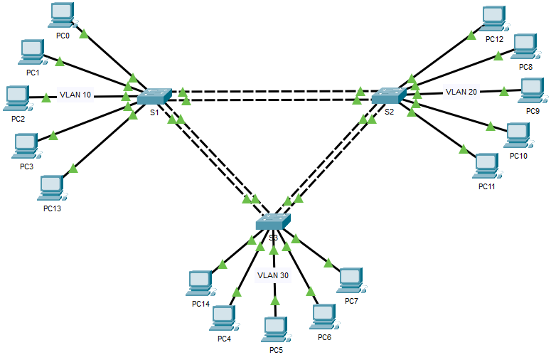

* DTP, Dynamic Trunking Protocol, is a trunking protocol that is developed and proprietary to Cisco which is used to automatically negotiate trunks between Cisco switches. Trunk negotiations are managed by DTP only if the port is directly connected to each other.
* Ethernet trunk interfaces support various trunking modes. Those interfaces can be configured as a trunk or non-trunk, or to initiate negotiating trunking to a neighbor interface or is waiting to receive a trunking negotiation message from another directly connected interface. Most Cisco switches nowadays use IEEE 802.1Q as their trunking type of choice because of less overhead compared to Inter-Switch Link (ISL).
* DTP, Dynamic Trunking Protocol, negotiation involves the exchange of DTP frames between two neighboring interfaces. When an interface is configured in switchport dynamic auto or dynamic desirable modes, it will initiate DTP negotiation in order to select its own trunking operational mode.
* When an interface is statically configured in access mode or trunk mode, it will normally participate in the DTP process by responding to DTP frames if it receives any.

S1

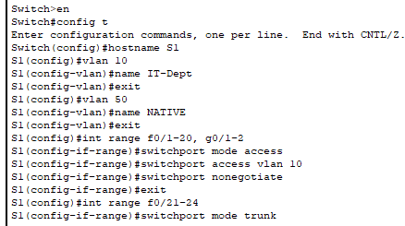

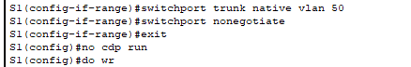

S2

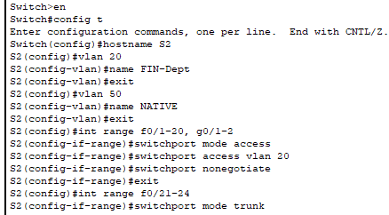

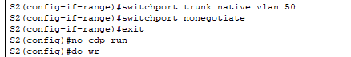

S3

